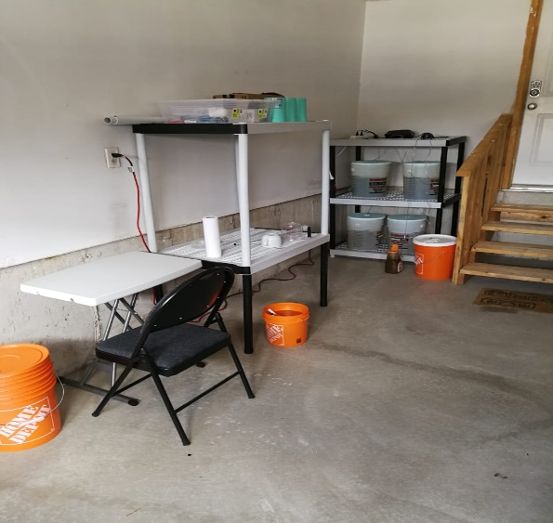

Canadian Rotifers

M a r k e t y o u r C o n t e n t

DMND projecy #2

**Marketing Objective:**

*Our marketing objective is: To acquire the first 100 blog views in October 2018.*

Currently, the blog has no views. The plan is to post an article to obtain the first ones.

**KPI:**

*The KPI for this project is: the number blog views in the end of October 2018.*

**Target Persona**

|  |  |  |
| --- | --- | --- |
| **Background and demographics** | **Target Persona Name** | **Needs** |
| ▪ Male, 30 years old  ▪ just married (looking forward for first kid  ▪ Computer Systems Analyst  ▪ Recently received a promotion  ▪ Lives in Oakville  ▪ Wife works as a school teacher  ▪ HH income $90k | Criss Garofalo | ▪ Lack of time for deep research on hobby  ▪ Requires an effective information source  ▪ Requires recommendations on cost effective solutions for hobby. |
| **Hobbies** | **Goals** | **Barriers** |
| ▪ Salt water aquarium  ▪ Travel  ▪ working out | ▪ Get ready for his first child  ▪ Save for a new home  ▪ Learn scuba diving  ▪ Get in better shape  ▪ Enjoy family life and friends | ▪ Work can be stressful and demanding  ▪ Busy tying to keep the pace with his industry  ▪ Hobby can demand time and money |

Photo by Pexels.com

**What is the theme and framework of your blog post?**

I decided to write a post about the reason to take the Digital Marketing Nanodegree Program.

In order to do so, I chose the ***pixar framework*** as the guide of my post.

I Will start telling he story of my relationship with my assistant, who is also my wife; and continue to describe our day in and day out, until (one day) she claimed that it was the right time to pursue our long-time postponed Project.

The post Will then tell the story of the steps we took and the difficulties we found until we decided that I had to enrol DMND

Write a blog post, with the theme you’ve chosen from the options above, in the space provided below:

**How to start small when you have a utopian project**

In my nine-to-five job, my assistant is also my wife. When we are working, I call her “Wife”; when we go out or just stay home doing family stuff, I call her “Assistant”. Assistant is normally bossy and thinks she knows more about me than I know myself, and I think she might be right on that one.

We know each other for a long time and we don’t need many words to communicate. At the beginning of this year (2018), Assistant looked directly at me and said*: Now is the right time*. I knew what she meant.

Assistant was talking about “The Project”, an idea we had been playing around with for a long, long time: to build the *perfect auto-sustained farm*. It’s about putting together an ideal farm in which the objective is not much to grow things, but where every element (crops and animals) works to keep the ecosystem’s balance.

The idea first came to us when we were studying highly productive ecosystems that naturally occur in the wild. It turns out that the main characteristic of these systems is that it supports not the lazy; instead, different species come to terms and work together in a symbiotic manner, to take over the use and maintenance of each of the layers of the food chain, in a way that nothing is wasted.

Some species like bacteria, fungi, plants, insects and fish specialize in such tasks, and that’s where the high productivity and high yields come about: when the products are put to work for the benefit of the whole system instead of just growing.

But every project requires time and money, and this particular one would demand huge quantities of both assets. We were passing for a goldilocks period in our work at the time, but our resources were still way far from what was needed to even start. I was skeptic.

*Bootstrapping*, Assistant said. I knew what she meant.

Next thing I knew, we were installing a home-made lab in our garage to grow beneficial bacteria. I took some time, but it was relatively easy. The hard part came when we had to find a way to test our results. We decided to use them as feed for an animal I had worked with before in the past, a vey tiny small animal called rotifer.

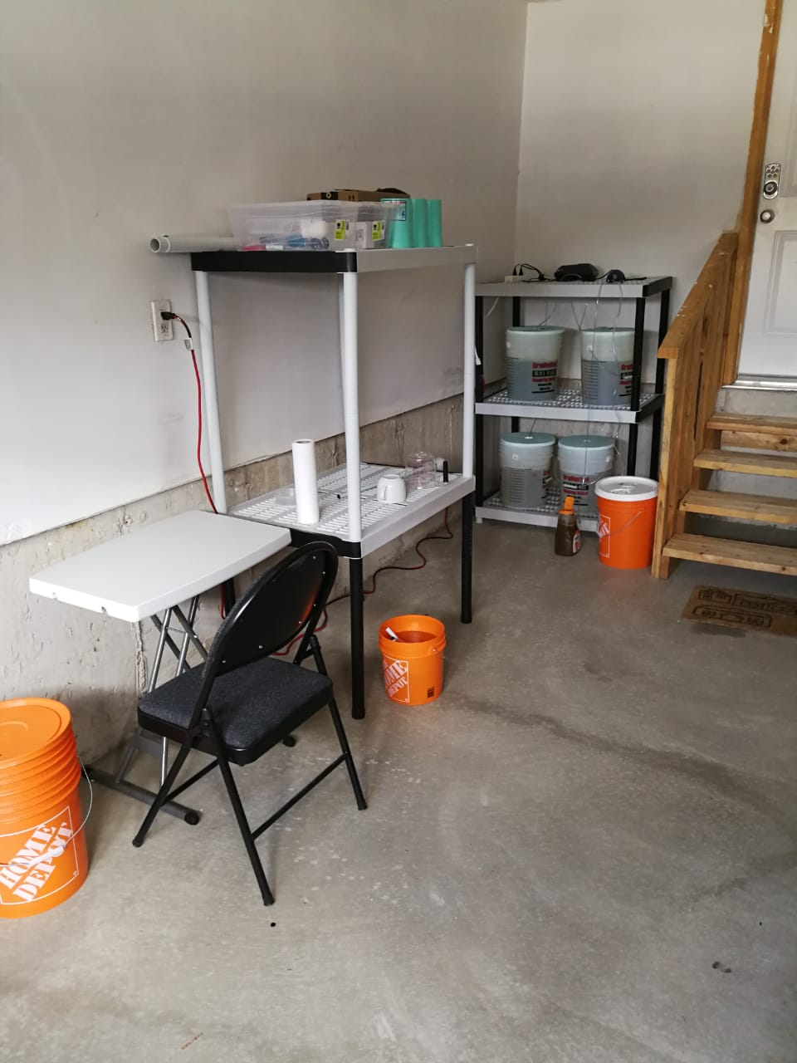

Home-made lab in our garage

Rotifers are a near-microscopic aquatic animal and one of the most common zooplanktons. I knew about them since college, but I really got acquainted with them some couple of years ago in an aquaculture project where we used them as feed for shrimp larvae.

Our home-made lab now holds two different species: beneficial bacteria and rotifers. Nowadays, they look happy together and we have managed to keep them healthy, in a sustainable way. *Now what?* I asked.

*Digital Marketing*, Assistant said. I knew what she meant.

Selling the rotifers could do the magic. It could not only provide funds to keep the project going but it could also give us a hint to where to direct the enterprise towards the perfect auto-sustained farm. But, how could a couple of limited-resources, biotechnical-oriented, pasta-lovers take advantage of what digital marketing can offer in an interconnected world? I asked in angst.

*Udacity*, Assistant said. And I knew what she meant.

**Blog Post**

*Write a short blurb with an image summarizing what your blog post is about. Post the link to your full post on the bottom of this slide:*

How to start small when you have a utopian project.



Actual photo of our home-made lab

It was about time to start the perfect auto-sustainable farm, but we didn’t have the time or the money. How could a couple of limited-resources, biotechnical-oriented, pasta-lovers take advantage of what digital marketing can offer in an interconnected world?

<https://seafarmer.ca/2018/09/25/how-to-start-small-when-you-have-an-utopical-project/>

**Summary**

*Choose three social media platforms you will use to promote your blog. Write a short explanation about why you chose those platforms.*

Facebook Pages

Since my company has no practical presence in the web. I think a Facebook page should be the best step to start with.

Facebook groups

Facebook also provides many ways to meet new people. Facebook groups is one social media where you can find people with a specific interest. In this case, I am planning to enroll in a group of Aquarium hobbyists

Quora

Quora is the best social media oriented to hobbyists. This is a social media where I could find technical oriented people and professionals looking for direct answers, It could help me to connect people who better adjust to the project’s target persona.

Note: The pic is a real photo I took of our home-made lab (no copyright required).

Platform 1 and Post

I created the company’s Facebook Page featuring the Canadian Raised Rotifers Project. Also, I posted the blog post in the Story section.

<https://www.facebook.com/rotiferz/>

Platform 2 and Post

I enrolled a Facebook Group called Ontario Saltwater Aquarium Community, and posted a link with the following intro:

Hello everyone. I’m a newcomer in this group and a complete rookie in the hobby. I grew interest in coral breeding by following a very unusual path, starting first by growing beneficial bacteria and rotifers. [This link tells the story](https://seafarmer.ca/2018/09/25/how-to-start-small-when-you-have-an-utopical-project/).

<https://www.facebook.com/groups/760608133983747/>

Platform 3 and Post

Finally, I posted the same link to Quora and ask for advice within the aquarium hobbyist community.

<https://www.quora.com/unanswered/Hello-everyone-I-m-a-newcomer-in-this-group-and-a-complete-rookie-in-the-hobby-I-grew-interest-in-coral-breeding-by-following-a-very-unusual-path-starting-first-by-growing-beneficial-bacteria-and-rotifers-Any-advice>

SeaFarmer is the result of research and development brought about by the professional partnership between Patricia Castano and Gustavo Silva whom, together, account for almost forty years of experience in the biotechnology field.

Their combined expertise includes the developing of several aquaculture projects, biotechnology consultancy and research, engineering implementation, marketing and commercialization.

Castano and Silva have successfully conducted production projects of the most diverse selection of aquaculture species (shrimp, tilapia, oysters, eels, and others), as well as one agriculture project (orchids). They both also account for key experience in biotechnology and engineering systems (irrigation, aeration systems, automated aquaculture and more)

**The general nature of Sea Farmer Consulting is to apply state of the art biotechnology to improve the life quality of our society and local communities in two ways: (1) Implementing ways to produce organic, pesticide–free, high quality and high yielding aquatic species by means of state of the art biotechnology. (2) Providing to the community innovative new ways of producing food, which are effectively productive and, at the same time, self-sustained and environmental positive.**